2+. Last Corner Pair of L Layer - Detailed
There are many possible configurations in this step. This section shows selected solutions for all possible situations (at least 4 turns long). Sometimes the initial U-turn (U, U' or U2) may be necessary to obtain one of the following situations. As you can see, all sequences are at most 6-turns long (the 6-turn sequences do not need an initial U-turn). This sets maximum number of face turns to solve the first four corners to 9 (3 + 6). However, the average number of moves should not exceed 7-8 turns.
Solved pair is in DL and the pair to be solved belongs to DR. D is white, F is green, R is orange, L is red, and B is blue. If you are not sure which position is displayed in some image perform the sequence backwards (reading right to left, R becomes R', R' R, F F', F' F, U U', and U' becomes U) to see the initial state on your cube.

Four-turn sequences.
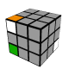 | F R F' R2 | 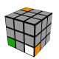 | R' F' U2 F
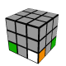 | R' F' U F | 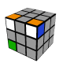 | F R2 F' R
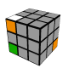 | F R' F' R2 | 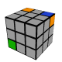 | R F' U2 F

Five-turn sequences.
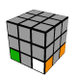 | F2 R F2 R' F2 | 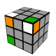 | R2 F R' F' R2 | 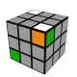 | R' U' R U' R2 | 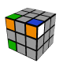 | R2 U' R2 U' R
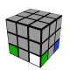 | R U2 R2 U R2 | 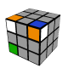 | R2 F R F' R2 | 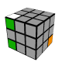 | R' U2 R U2 R | 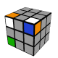 | R2 U' R U R'
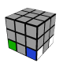 | R' U R2 U' R | 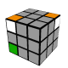 | R F R F' R2 | 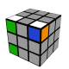 | R U2 R U2 R | 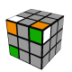 | R2 U' R' U R'
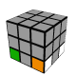 | R2 U' R2 U2 R' | 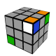 | R' U2 R2 U R2 | 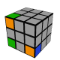 | R2 U R' U2 R' | 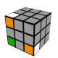 | R' U' R' U R'
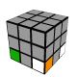 | R' U' R U2 R' | 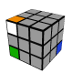 | R' U2 R' U' R2 | 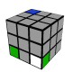 | R U' R U2 R | 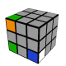 | R' U' R2 U' R
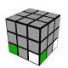 | R U' R U' R | 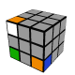 | R2 U2 R' U' R2 | 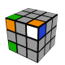 | R U R' U2 R' | 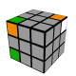 | R U' R2 U' R
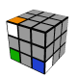 | R' F R F' R2 | 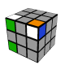 | R' U R2 U R2 | 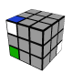 | R' U R2 U R | 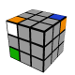 | R U' R U R'

Six-turn sequences.
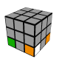 | F' U F R U R' | 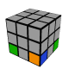 | R' F U2 R2 F R' | 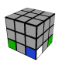 | R' U2 F R F' R2

